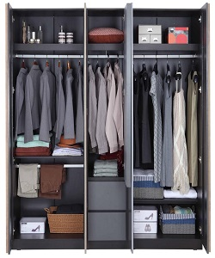

Wardrobe

$250.38

Availability: In stock

Description

Storage Wainscoting is a unique storage solution that offers a halfway alternative to cabinet and closet. This wardrobe combination is just as good looking on the outside as it is clever on the inside. Adjustable feet make it possible to compensate any irregularities in the floor. Powerfully designed as per convenience, Modular Wardrobes by Durian storage into style & trend.